**Introduction**

Bird diversity is important for keeping ecosystems balanced and healthy. This study looks at 98 bird species in a specific region of Australia, spread across eight zones. The data include bird flight behaviors (gliding, flapping, diving) and weather conditions, offering a chance to explore how birds adapt to their environment. It also provides habitat types and location coordinates for detailed ecological analysis.

Research Questions:

1. Predict bird species using flight height and habitat?  
   In this question on the base of two exploratory variables Height_Max and HABITAT, we predict bird belong to which species. (LDA is best choice for categorical variables
2. Is there a link between maximum flight height, species, and habitat?  
   This question checks if certain species fly higher or lower depending on their habitat. (Multiple Linear Regression) Independent variables = Species and flieght height , Dependent Variable = Max Height / LDA
3. Does adding geographic coordinates to flight height and site ID improve species prediction?  
   We want to see if using location data with flight height and site ID helps identify species more accurately.   
   LDA because we have demograghic variable  
   Use LDA – First without geographic(lang, latitide)-> check hit rate, misclassification  
   then LDA with additional geographi variablkes -> check hit rate and misclassification  
   Other option is K-Means Clustering -🡪 It suites more

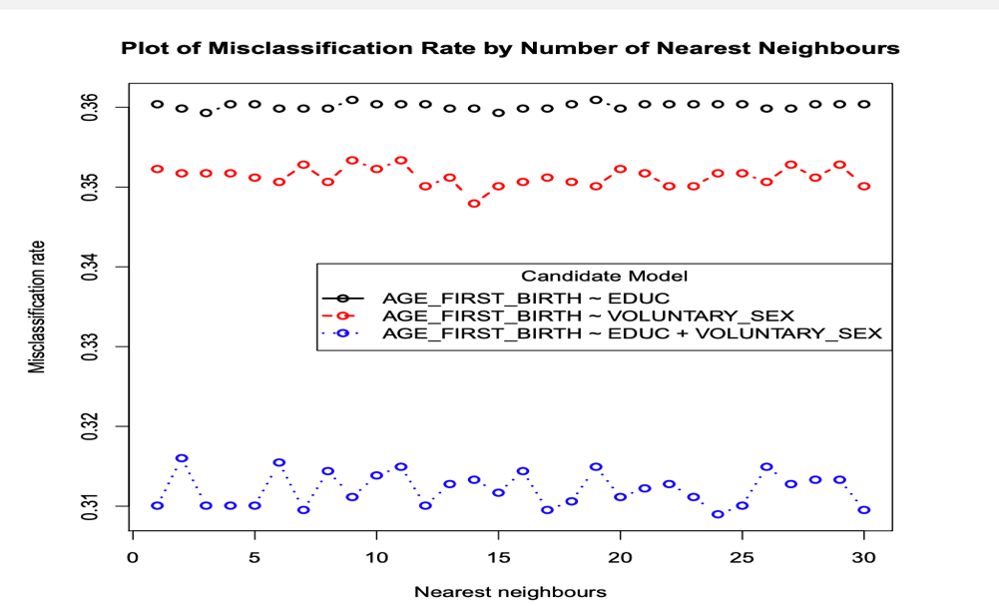

Motivation:This study helps us better understand bird behaviors and their preferred habitats. By predicting species and understanding their flight patterns, we can improve conservation efforts and ecological planning to protect bird diversity.

What data cleaning technique should be used, because lot of NA values found